**WORKSHOP MODULE**

1. **Screens To be developed**
2. **Masters**
3. Workshops (Use table ‘CMN_Mst_LocationGroup’)

* ID
* WorkshopNameEn
* WorkshopNameAr
* Governorate
* Willayat
* Co-ordinates

1. Technician Types (create table ‘WSP_Mst_TechnicianTypes’)

* ID
* TechTypeNameEn
* TechTypeNameAr
* ChargePerHr

1. Technicians (create table ‘WSP_Mst_Technician’)

* ID
* EmpID(Varchar)
* Name

1. Service Types (create table ‘WSP_Mst_ServiceTypes’)

* ID
* ServiceTypeNameEn
* ServiceTypeNameAr

1. UOM( create table ‘WSP_Mst_UOM’)

* ID
* UOM_Code
* UOM_NameEn
* UOM_NameAr

1. ItemMaster (create table ‘WSP_Mst_ItemMaster’)

* ID
* ItemCode
* ItemName
* Price
* UOM
* MinQty

1. VehicleType (create table ‘WSP_Mst_VehicleType’)

* ID
* VehicleTypeNameEn
* VehicleTypeNameAr

1. Brands (create table ‘WSP_Mst_Brands)

* ID
* BrandNameEn
* BrandNameAr

1. Vehicles (create table ‘WSP_Mst_Vehicles’)

* ID
* VehicleTypeID
* RegNo
* FleetNo
* RegExpiryDate
* Description
* BrandID
* YearOfManufact
* FirstRegDate
* EngineNo
* ChasisNo
* PurchaseDate
* PurchaseValue
* ServiceInterval_KM
* ServiceInterval_Months
* Status(Inuse,Scrap,sold)

1. Vehicle Documents (create table ‘WSP_Utl_VehicleDocs’)(not a new screen)

* ID
* VehicleID
* DocURL

1. Drivers (create table ‘WSP_Mst_Drivers’)

* ID
* EmpID (varchar)
* DriverName
* LisenceNo
* LisenceExpiryDate

1. Customers (create table ‘WSP_Mst_Customers’)

* ID
* CustomerName
* ContactPerson
* ContactNo
* ContactEmail

1. Services (create table ‘WSP_Mst_Services’)

* ID
* ServiceTypeID
* ServiceNameEn
* ServiceNameAr
* IsItemRequired

1. **Configurations**
2. Service Configuration

|  |  |
| --- | --- |
| Service Type : (select) | Vehicle Type : (Select) |
| Service 1 | |
| Service 2 | |
| Service 3 | |
| Service 4 | |
| Save | |

Create table (WSP_Cnf_Services)

* ID
* ServiceTypeID
* VehicleTypeID
* ServiceID

1. **Operations**
2. ServiceBooking(create table ‘WSP_Opr_ServiceBooking’)

* ID
* VehicleID
* ServiceTypeID
* BookingDate
* Kms
* Workshop

1. Workshop Admission

* ID
* ServiceBookingRefNo
* Driver
* Date

1. Inspection

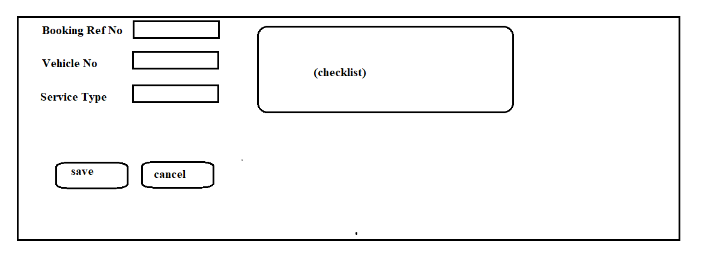

1. Job Card
2. Material Requisition(To Store)

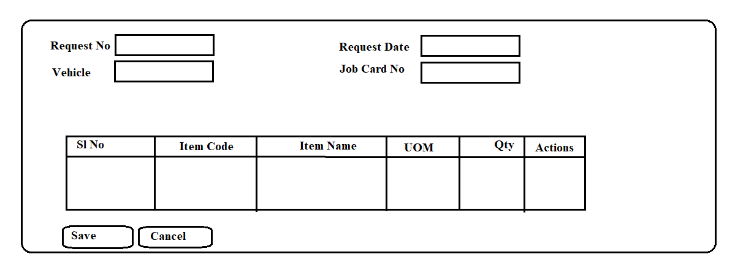

1. View Material Requests (From Store)

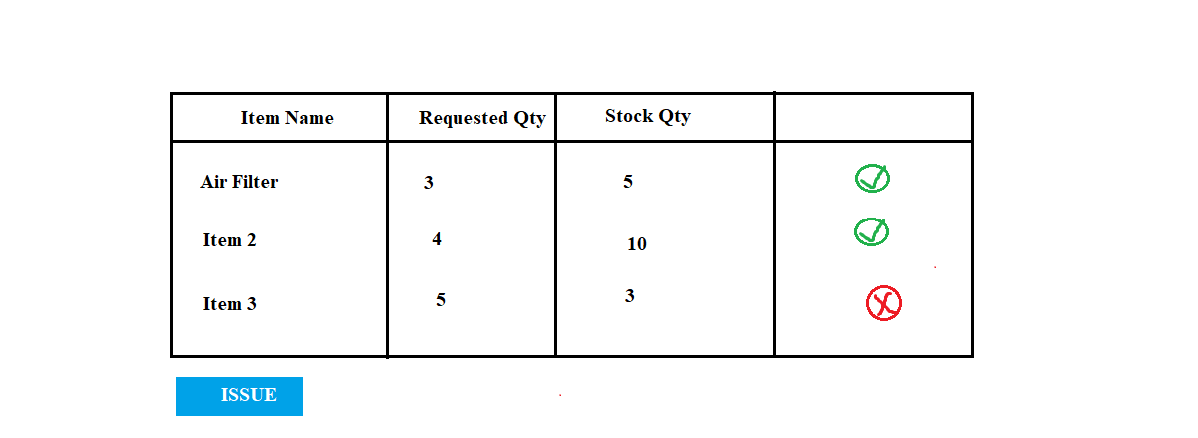

1. Choose Vehicle No From The List

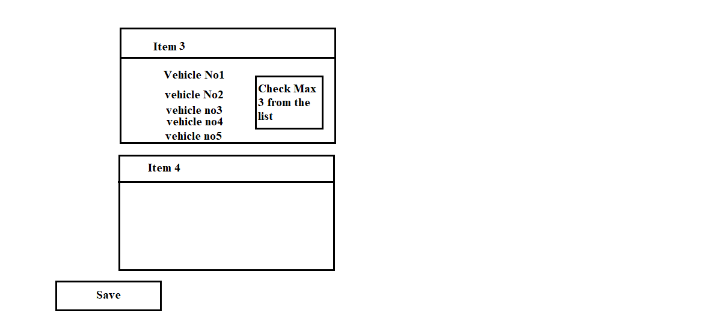

1. View Request (Purchase Team)=>make LPO
2. GRN
3. Item Receipt (Store)
4. Timesheet Entry
5. Costing Sheet
6. Gate Out